PROJECT REPORT TEMPLATE

**1 OVERVIEW**

1.1INTRODUCTION:

The title of the project allotted to our group is JOB APPLICATON TRACKING SYSTEM. This is an all-in-one human resource software that automates the hiring process, helps HR teams efficiently manage every part of recruitment, and solves recruiters’ challenges and pain points.

1.2 PURPOSE:

APPLICATION TRACKING SYSTEM has stores job candidate information like resumes, cover letters, references, and other recruitment and hiring data that HR teams can easily access and organize.

**2 PROBLEM DEFINING AND DESIGN THINKING**

2.1 Empathy map

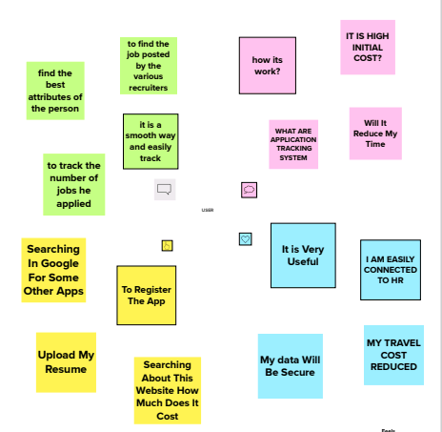

2.2 Ideation and Brainstorming map

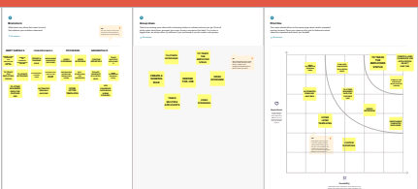

**3 Result**

3.1 Data Model:

|  |  |  |
| --- | --- | --- |
| OBJECT NAME | FIELD LABEL | DATA TYPE |
| RECRUITER | JOB TITLE | TEXT |
| JOBS | DESCRIPTION | TEXT AREA |
| JOBS | LOCATIONS | TEXT |

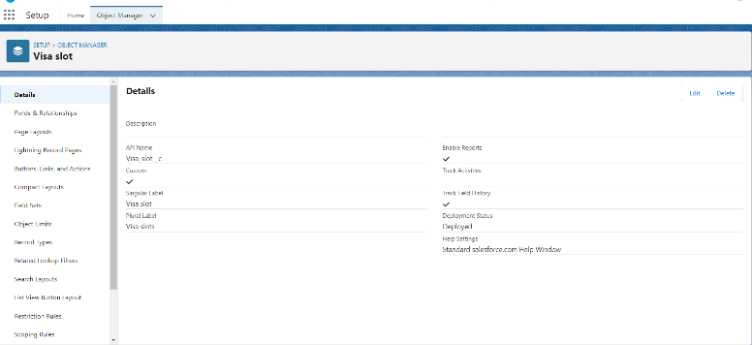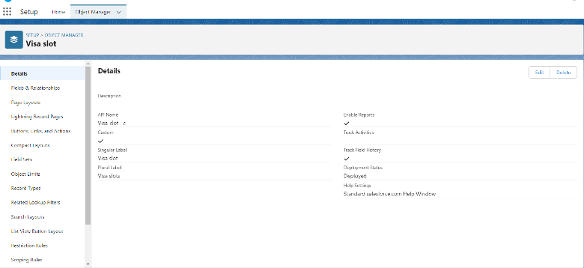

**3.2 Activity and screenshot:**

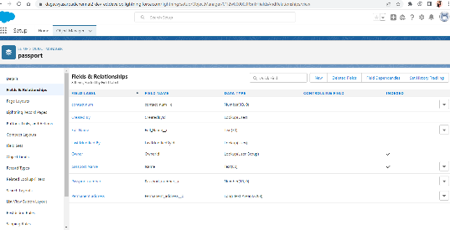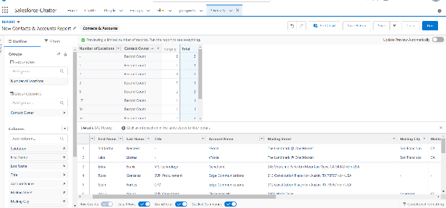

**4 Trailhead profile public URL:**

Team Lead: [https://trailblazer.me/id/](https://trailblazer.me/id/durga3018p)sarsm3

Team Member1: [https://trailblazer.me/id/](https://trailblazer.me/id/snehaasi)vvenkateshwari

Team Member2: [https://trailblazer.me/id/](https://trailblazer.me/id/preethi08)ppoovarasi

Team Member3: [https://trailblazer.me/id/](https://trailblazer.me/id/dhana02)psangeethad

**5 Advantages and Disadvantages:**

|  |  |
| --- | --- |
| **Reduces time sent with administrative tasks** | **Job application tracking system is missing qualified applicants due to wrong keyword selection.** |
| **Provides better and faster CV screening** | **Automatic elimination of resumes that software cannot recognize and interpret is another drawback.** |
| **Facilities collaborative Hiring** | **AN applicant tracking system disadvantage is that they are open to manipulation** |
| **Improves the quality of hire** | **System experiences similar frustrating technical issue. Applications can be rejected** |

**6 Applications:** **Create stronger job descriptions**

**Organizations create a job requisition because they have identified a critical business need that current staffing levels do not address. The job description must translate this business need into core responsibilities. But it must also capture the attention of the most qualified candidate. An ATS has keyword-rich templates for job descriptions that attract the right attention, at the right time, and in the places where top candidates are looking.**

**Extend recruiter reach and reduce friction**

**An ATS allows recruiters to match job requisitions to the job-posting sites and the social media channels most appropriate for specific candidates. An ATS also maximizes visibility for internal job boards, while requiring fewer clicks and eliminating barriers for prospective employees.**

**Automate and increase efficiency**

**An ATS can transform and automate manual processes across the hiring cycle with tools like automated job posting and communication, and digitized, flexible interview scheduling. Employers can reduce their dependence on decentralized, paper and email processes. Doing so prevents qualified candidates from falling through the cracks. It also eliminates mistakes and slowdowns while moving applicants more quickly through the hiring funnel to improve cost-to-hire metrics. Digitizing and centralizing sensitive data also improves the security of that data.**

**Improve visibility and collaboration across recruiting teams**

**Just as candidates have become more dispersed, so have recruiting teams. Many organizations struggle with efficiency because of poor collaboration caused by inconsistent processes and ineffective tools. An ATS allows entire recruiting teams to see where a candidate is in the process, what touchpoints have occurred, and remaining next steps. Alerts can be established so no critical responsibilities are overlooked and so good candidates aren’t lost.**

**7 Conclusion:**

**Applicant tracking system for recruiters is a very effective hiring solution that most of the successful recruiters utilize. Because without it, there is a good chance that your process of moving applicants through different stages can become very difficult.**

**8 Future Scope:**

**The world is moving into automation and AI, and leads way to the new age Applicant Tracking System(ATS). Read further to understand what the future might be like for the ATS.**

**Future of Applicant Tracking System**

**The world knows that Applicant Tracking Systems (ATS) made their way into the recruitment domain just a few years ago. Although, previously, ATS solutions were implemented only by a few companies that could bear the heavy investment costs, now their use in the HR arena has risen to a great extent. According to a recently released survey report, the majority of staffing firms worldwide will opt for an Applicant Tracking System by the end of 2020 to improve the overall talent acquisition efficacy, in this scope the future of ATS definitely looks bright.Read on to find out more about the evolution of Applicant Tracking Systems and how the same has been beneficial for the new breed of recruiters.**